Item #10: The Handwriting on the Wall
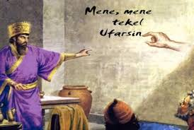
Category: The Bible

What I Already Know About This Item:
__________________________________________________________
__________________________________________________________

(For this slide you should be writing down 3 things: name of allusion, background information, how it is used today.)

According to the Book of Daniel, Belshazzar, the King of Babylon, gave a great banquet, at which the guests praised the gods of silver, gold, bronze, wood, iron, and stone. Suddenly, a human hand appeared and wrote mysterious words on the wall. Daniel translated the writing, saying it prophesied that Belshazzar’s reign was over. That night, the king was killed.

The phrase “handwriting on the wall” refers to an indication that doom or misfortune is coming.

(For this slide you should be writing down 2 things: 1 given example and 1 original example.)

Examples: (copy ONE)

I took my boss’s suggestion that I might want to start updating my resume’ to be the handwriting on the wall; I knew it wouldn’t be long until my job, like many others in our company, would be cut.

I was completely shocked when my boyfriend broke up with me, but my friends said I should have seen the handwriting on the wall when he kept “forgetting” to call me and began to spend all his free time with his buddies.

My Own Original Example: (write ONE)

