Item #11: Albatross Around One’s Neck
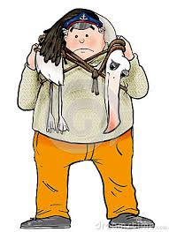
Category: Literature
What I Already Know About This Item:
__________________________________________________________
__________________________________________________________
(For this slide you should be writing down 3 things: name of allusion, background information, how it is used today.)

In “The Rime of the Ancient Mariner,” a poem by Samuel Taylor Coleridge, a sailor shoots an albatross, a bird considered to be a good omen. As punishment, the sailor is forced to wear the carcass of the albatross around his neck.

An “albatross around a person’s neck” is a burdensome, ongoing problem.

(For this slide you should be writing down 2 things: 1 given example and 1 original example.)

Examples: (copy ONE)

Although we have an outstanding basketball team, our biggest rival continues to be the albatross around our necks. We haven’t won a game against them in over three years.

Although credit cards are convenient, the temptation to overspend can be great, and before you know it, you have an albatross around your neck with debt that is seemingly impossible to pay off.

My Own Original Example: (write ONE)

