Item #: Prometheus/Promethean
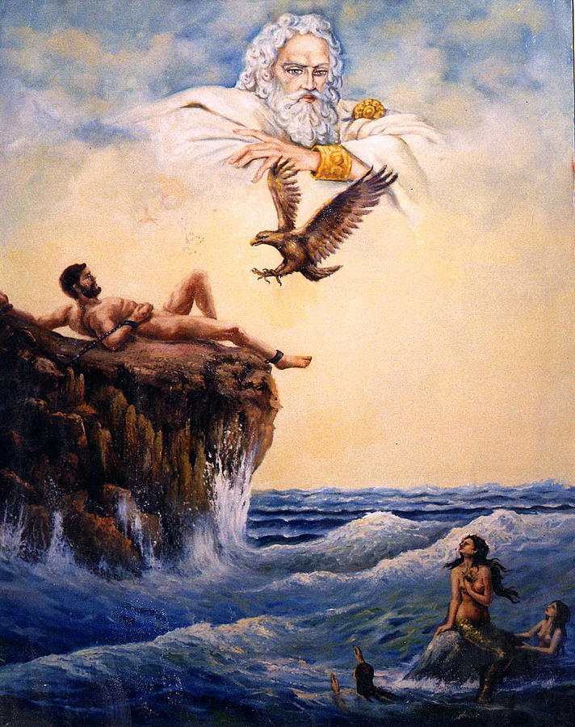
Category: Mythology and Legend
What I Already Know About This Item:
__________________________________________________________
__________________________________________________________
(For this slide you should be writing down 3 things: name of allusion, background information, how it is used today.)

In Greek mythology, Prometheus was a demigod known for his cunning. Having been tricked by Prometheus, Zeus withheld fire from mankind. In response, Prometheus went to Mount Olympus and stole some fire, which he gave to man. Zeus punished him by chaining him to a rock; each day an eagle came and ate out his liver, which grew back each night. He was eventually rescued by Hercules.

Prometheus represents valiant resistance to authority or rebellion against established order of the universe. The adjective “Promethean” refers to an act of such resistance.

(For this slide you should be writing down 2 things: 1 given example and 1 original example.)

Examples: (copy ONE)

In one of his novels, Thomas Hardy calls lighting a fire in winter a Promethean act, in which man tries to rebel against the approaching cold.

The subtitle of Frankenstein is “The Modern Prometheus” because Victor Frankenstein dares to overstep the bounds of nature and create life.

My Own Original Example: (write ONE)

