Item #13: Juggernaut
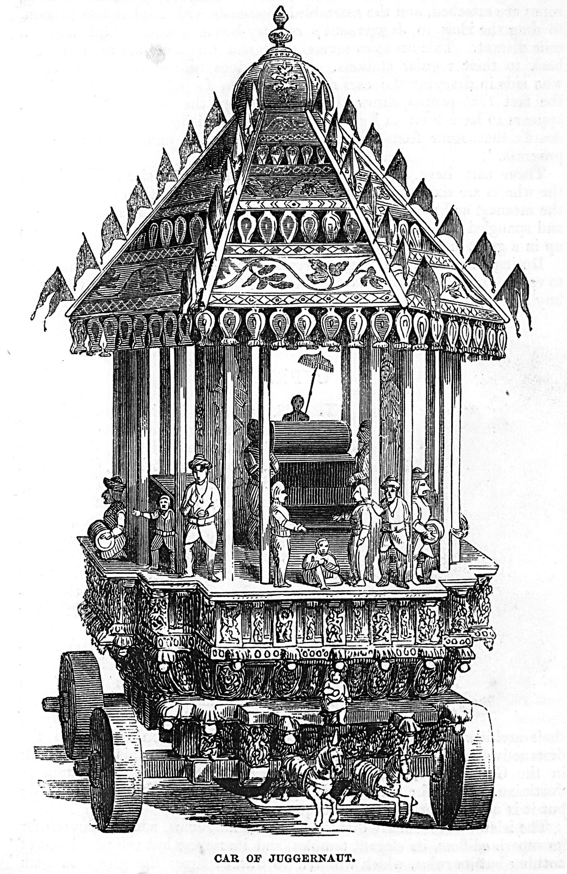
Category: History, Culture, and Ideas
What I Already Know About This Item:
__________________________________________________________
__________________________________________________________
(For this slide you should be writing down 3 things: name of allusion, background information, how it is used today.)

“Juggernaut” is the name of a Hindu deity. His image is carried in an annual procession on a large cart. According to legend, devotees threw themselves in front of the cart and were crushed, believing this guaranteed immediate entry to Paradise.

A “juggernaut” is any force, especially a destructive force, that defies opposition.

(For this slide you should be writing down 2 things: 1 given example and 1 original example.)

Examples: (copy ONE)

Some people see technology as a juggernaut that has taken over our lives; we are so much at its mercy that when computers go down, we are practically helpless.

The candidate raised so much money, in addition to the personal wealth he already possessed, that his campaign became a juggernaut, and no one had a chance of defeating him.

My Own Original Example: (write ONE)

