Item #14: Red Herring
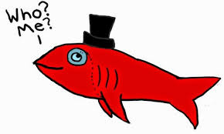
Category: Language and Idioms
What I Already Know About This Item:
__________________________________________________________
__________________________________________________________

(For this slide you should be writing down 3 things: name of allusion, background information, how it is used today.)

There are several explanations for the origin of this phrase. A herring is a fish, and when it is “cured,” or smoked and salted, it turns red and has a very strong, pungent smell. One explanation is that British fugitives in the 1800s would drag a red herring across their trail, thus confusing the hounds and diverting them from following the convicts’ scents. Another explanation is that red herrings were dragged across the ground to train hunting dogs to follow scent, and later were used to throw the dogs off the trail and thus prolong a foxhunt. A variation of this explanation is that poachers used the herrings to divert hunting dogs so that they could get the game for themselves.

In any case, the phrase “red herring” refers to diverting someone onto a false trail or distracting a person from the true issue.

(For this slide you should be writing down 2 things: 1 given example and 1 original example.)

Examples: (copy ONE)

Asked about her stance on raising taxes, the candidate began to speak about her opponent’s record on childcare issues. Obviously, this was a red herring, and the reporter did not let her get away with it.

The detectives were hopeful when they found fingerprints on the windowsill, but this turned out to be a red herring; the prints belonged to the window washer.

My Own Original Example: (write ONE)

