Item #2: Witch Hunt
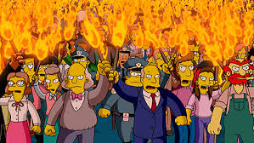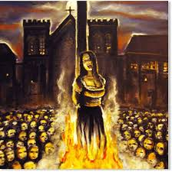
Category: History, Culture, and Ideas
What I Already Know About This Item:
______________________________________________________________
______________________________________________________________

(For this slide you should be writing down 3 things: name of allusion, background information, how it is used today.)

In 1692, in Salem, Massachusetts, hysteria about supposed witches led to the arrest of many people, and the execution of twenty. Often, the accused were simply social outcasts and were convicted on flimsy evidence that could neither be proved nor disproved.

A “witch hunt” refers to a campaign against a particular group of people, often those holding unorthodox opinions or behaving in an unconventional manner.

(For this slide you should be writing down 2 things: 1 given example and 1 original example.)

Examples: (copy ONE)

The McCarthy hearings during the 1950s are often described as a witch hunt because a national hysteria arose about people’s supposed connections to the Communist Party, and much of the evidence accepted as truth was mere hearsay.

Despite denials by athletes and repeated testing for banned substances, some sports writers continue the witch hunt; the writers assume that any athlete who excels dramatically must be cheating in some manner, even when all evidence indicates that there has been no wrongdoing.

My Own Original Example: (write ONE)

