Item #3: Throw Down the Gauntlet
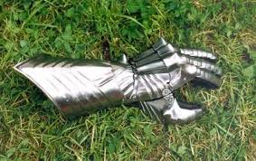
Category: Language and Idioms
What I Already Know About This Item:
__________________________________________________________
__________________________________________________________
__________________________________________________________

(For this slide you should be writing down 3 things: name of allusion, background information, how it is used today.)

In the days of knighthood and chivalry, if a knight wanted to challenge another knight to a duel, he would throw down his heavy glove, or “gauntlet.” If the challenged knight picked up the gauntlet, this indicated that he had accepted the challenge.

“Throwing down the gauntlet” refers to issuing a challenge, especially issuing that challenge in a dramatic manner.

(For this slide you should be writing down 2 things: 1 given example and 1 original example.)

Examples: (copy ONE)

Karen and Amy, both sprinters, argued continuously about who would do better at longer distances. Finally, Amy threw down the gauntlet and challenged Karen to a two-mile race.

Our parents threw down the gauntlet, offering fifty dollars to any of us who could go an entire week without watching television or playing video games.

My Own Original Example: (write ONE)

