Item #4: The Muses
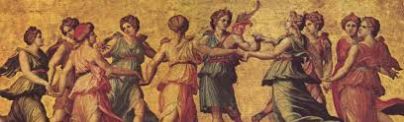
Category: Mythology and Legend

What I Already Know About This Item:
__________________________________________________________
__________________________________________________________
__________________________________________________________

(For this slide you should be writing down 3 things: name of allusion, background information, how it is used today.)

In Greek mythology, the Muses were nine goddesses who presided over the arts. They gave inspiration to mortals. Typically, an epic begins with an invocation to the Muse, in which the poet asks the Muses to inspire him as he writes or sings his story.

Today, a “Muse” is someone’s source of inspiration, especially in artistic, creative endeavors.

(For this slide you should be writing down 2 things: 1 given example and 1 original example.)

Examples: (copy ONE)

It is common for fashion designers to select a particular woman as a Muse, keeping her in mind as he or she designs a new line of clothing.

I really felt I needed to work on the song I am writing this weekend, but it seemed the Muse had abandoned me; I couldn’t seem to make any progress at all.

My Own Original Example: (write ONE)

