Item #6: Tower of Babel
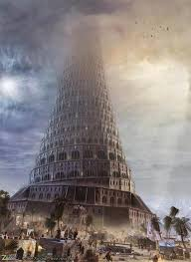
Category: The Bible
What I Already Know About This Item:
__________________________________________________________
__________________________________________________________
(For this slide you should be writing down 3 things: name of allusion, background information, how it is used today.)

According to the Book of Genesis, Noah’s descendants decided to build a tower that would reach Heaven itself. Concerned that mankind was becoming too powerful, God decided to introduce different languages so that people could not understand each other and thus could not complete the tower.

“Tower of Babel” or simply “Babel” can refer to any noisy confusion. This confusion may or may not be caused by the presence of different languages.

(For this slide you should be writing down 2 things: 1 given example and 1 original example.)

Examples: (copy ONE)

It was like Babel on the first day of summer camp, with friends who hadn’t seen each other for a year reuniting and seemingly all talking at once.

When the delegates from all the different nations arrived for the conference, the lobby sounded like the original Tower of Babel.

My Own Original Example: (write ONE)

