Item #7: Pollyanna
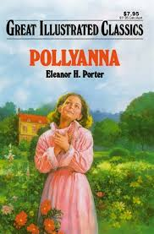
Category: Literature
What I Already Know About This Item:
__________________________________________________________
__________________________________________________________
(For this slide you should be writing down 3 things: name of allusion, background information, how it is used today.)

Pollyanna is a character in children’s stories written by Eleanor H. Porter. She is a little girl who teaches everyone she meets to play the “glad game,” a game in which a person tries to find something to be glad about in any situation, no matter how bad the situation is.

A “Pollyanna” has come to refer to someone who is unusually optimistic and always looking at the bright side. The term often has connotations of being excessively cheerful and naïve.

(For this slide you should be writing down 2 things: 1 given example and 1 original example.)

Examples: (copy ONE)

I hate to sound like a Pollyanna, but I think maybe it’s a good think you lost your job. I believe you will have the opportunity to find a position that will be more fulfilling for you.

The mayor must be living in some Pollyanna dream world if he thinks the city is getting better and better under his leadership; almost every problem the city faces has worsened since he took office.

My Own Original Example: (write ONE)

