Item #9: Bedlam
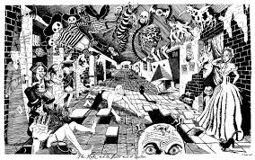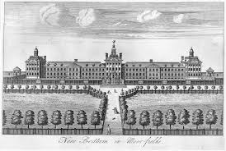
Category: Language and Idioms

What I Already Know About This Item:
__________________________________________________________
__________________________________________________________

(For this slide you should be writing down 3 things: name of allusion, background information, how it is used today.)

“Bedlam” was the popular nickname for London’s Hospital of St. Mary of Bethlehem, a mental hospital founded in the fourteenth century. Because the patients were simply housed there with little treatment, they tended to wander the halls talking to themselves or screaming and fighting with each other.

“Bedlam” has come to mean wildly chaotic or extremely raucous and noisy.

(For this slide you should be writing down 2 things: 1 given example and 1 original example.)

Examples: (copy ONE)

It is bedlam in the halls after the final bell rings on the last day of school before summer vacation.

My parents came home expecting to find bedlam after they left us alone for the weekend, but they were surprised to find the house even neater and cleaner than it was before they left town.

My Own Original Example: (write ONE)

