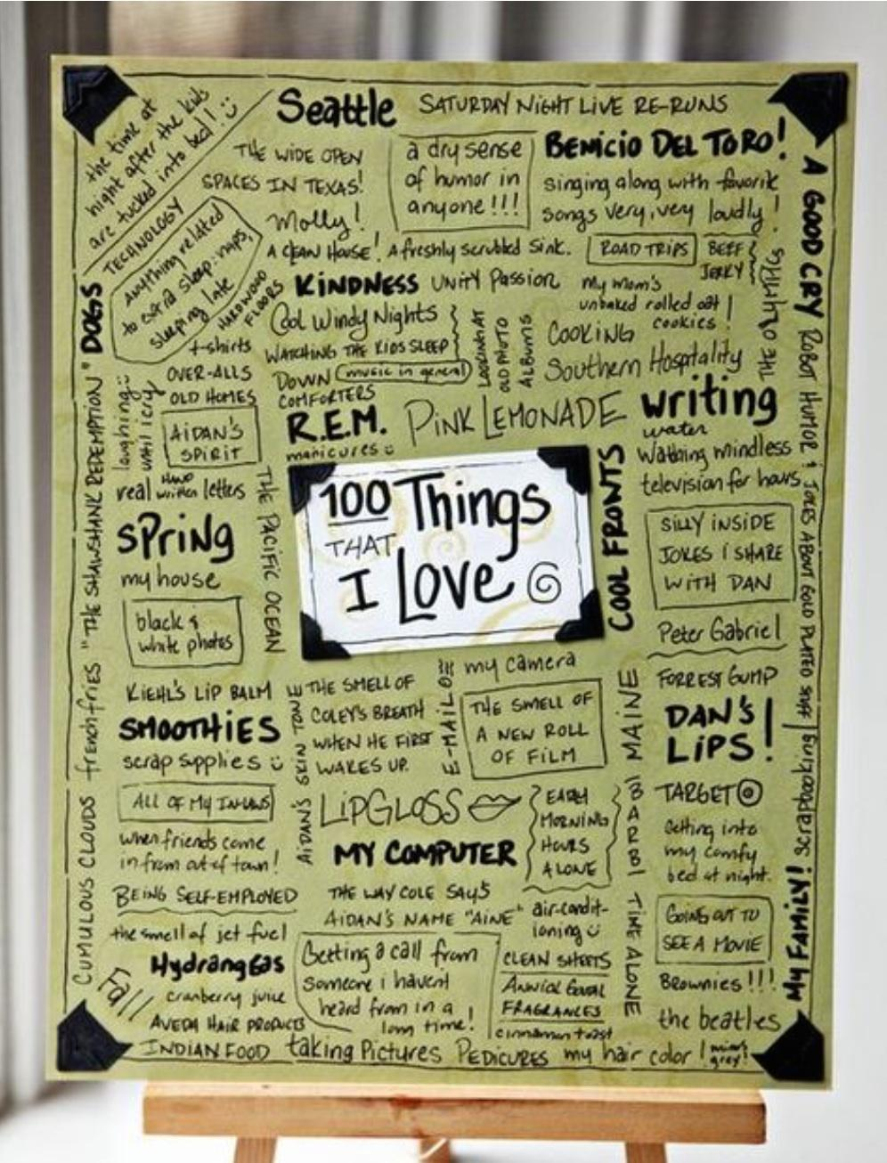
100 Ways to be
AWESOME

- Students use ONE page in their writing journal to create this 100 Ways to be Awesome topic list.

- Turn journals to write in different directions … the goal is to fill the page full of potential writing topics. To the right, is an example of what the page should look like when finished.

- BOLD or BOX some ideas to allow it to stand out from other ideas.

- Add a splash of color! Use colored pens/pencils.

Teacher Topics Guide:
5 Adjectives that describe YOU best
10 Places you have been or want to go someday
10 Important People in your life (bold)
5 Favorite Quotes (write around the page edge)
5 Favorite Characters - books, movies TV shows
10 Things you like to do for fun (box around)
5 Things you like about yourself
10 Favorite books, movies, TV shows, songs
5 Most interesting words
5 Things you are Thankful for (box around)
5 Things that make you nervous
5 Personal/Academic goals
5 Things from nature that inspires you (draw a picture of one or two!)
5 Top 5 tasks on your Bucket List
10 Basic Favorites - colors, foods, holidays, smells, drinks, products, numbers, etc.

