BENEDICT ARNOLD
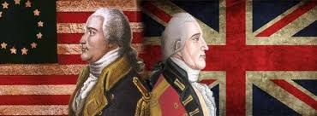
HISTORY:
- military leader
- American revolution
- Traitorous
- Surrender a key fort to the British
- Escaped and lived rest of his life in Britain

TODAY:
- traitor

EXAMPLE:
My sister called me Benedict Arnold when I decided to attend college at OSU since both she and my parents attended OU. The schools are long time rivals.

