COALS TO NEWCASTLE
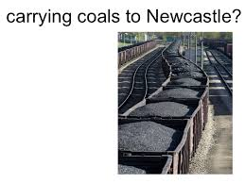
HISTORY:
- coal-mining city
- England
- Superfluous

TODAY:
- giving a superfluous gift
- making a contribution that is gratuitous and unnecessary

EXAMPLE:
Although putting one more pair of shoes in her closet was like carrying coals to Newcastle, Veronica could not resist the sale, and she ended up buying three new pairs.

