SCYLLA AND CHARYBDIS
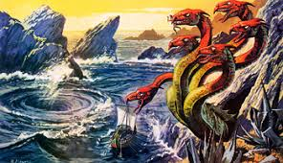
HISTORY:
- Greek mythology
- Many-headed sea monster
- Cave on one side of a narrow strait
- Steer ships very carefully between the two

TODAY:
- between two equals in which avoiding one means getting closer to the other
- “between a rock and a hard place”

EXAMPLE:
Caught between the Scylla of raising taxes and angering voters and the Charybdis of cutting vital city services, the council knew their decision was not going to be an easy one to make.

