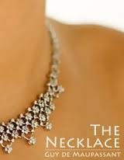

Choose ONE of the following questions and answer in proper open-ended response format. Your answer will be typed and placed in the middle of your necklace project.

1. Would you consider Mme. Loisel a woman who is content? Why or why not? Use evidence from the story to back up your answer.

OR

2. What is a possible theme for Guy de Maupassant’s “The Necklace”? Use events and text evidence from the story to back up your response.

OR

3. How is irony used at the end of Guy de Maupassant’s “The Necklace”? Use text evidence from the story to back up your response.

