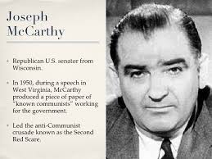
During the 1950s, known as the McCarthy era, people were blacklisted because they were accused of having some connection to Communism. During this period, people stopped expressing their beliefs and ideas. They were scared they would lose their livelihood, or worse. In Inherit the Wind, Lawrence and Lee were less concerned with the Scopes trial and more concerned with the censoring or limiting of an individual’s freedom to think. They used the evolution as a metaphor for control over an individuals thoughts or beliefs. Inherit the Wind is their response to the McCarthy era.

