What does it mean when a teacher tells you to elaborate?

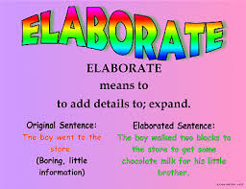

Also, some words show no details and are “vague” (uncertain, indefinite, or unclear in meaning).

For this activity, you are going to practice elaborating the vague word “AWESOME”.

Step 1: Choose a topic you think is awesome. It can be anything you want: baseball, LeBron James, cats, the sound of rain, your little brother, lasagna, the mountains in Colorado…anything.

Step 2: Find a pleasing picture of that topic on the internet and save it.

Step 3: Open up a Google Doc and write an acrostic poem about your topic that elaborates specifically upon why your topic is awesome. See the example below. You will spell out AWESOME going down vertically in BOLD print capital letters. Then each line will going across horizontally will start with that letter of AWESOME. The lines themselves should not be in bold print (only the letters of AWESOME should).

Step 4: Add on the following items-
- a title (name of the item – make sure you
capitalize the title correctly)
- include your first and last name – By:
- center your picture below your poem

Step 5: Revise and use an online thesaurus to see where you might add better words. Add figurative language and vivid verbs. Double check that your verb tense is consistent.

Step 6: Edit for spelling and grammar errors

Step 7: Print and turn in

Hawaii is Awesome
By: Mrs. Greenlaw

A lways in bloom with hibiscus and orchids
W aters frosted with waves, peppered with surfers
E nchanted jungles envelop the
S ummertime luaus that
O ffer retreat from the
M undane city or the
E veryday suburb.

Kylie is Awesome
By: Mrs. Greenlaw

A lways waited for the boys with an anxious heart at the front door
W indow at 3:30
E very day after school.
S irens going off made her run outside and howl like a wolf.
O n the chaise lounge she would curl up and sleep.
M oved over so the cats could eat her food.
E njoying the treats God is giving her in Heaven today.

