Name_________________________________________________
Period ____

1. When speaking of men, Old Major warned that the animals “must not come to resemble him” (Orwell 21). Discuss two ways the animals do come to resemble man in chapter 4. Use evidence from the text and proper parenthetical citation to back up your answer. Use only the box provided.

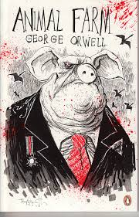
2. People are often more apt to follow their leaders rather than critically think for themselves. Discuss how Chapter 5 of Animal Farm illustrates this observation. Use evidence from the text and proper parenthetical citation to back up your answer. Use only the box provided.

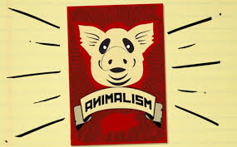

3. Use the timeline given at the start of the Power and Responsibility unit and determine the allegorical elements of Chapter 5 to the Russian Revolution. Discuss 2 items in chapter 5 and how they are allegorical. Use text evidence to back up your answer and proper parenthetical citation. Use only the box provided.

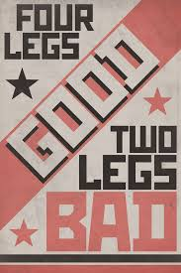

4. Discuss the new role of Snowball in Chapter 6. Is this role effective or ineffective? Use text evidence with proper parenthetical citation to back up your answer.

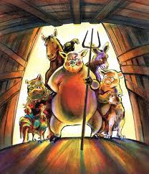
5. Read the AoW “Abuse of Power” on the Google site about TX Gov. Ricky Perry. Discuss how it relates to Animal Farm. Make sure you include evidence from BOTH texts in your answer.

