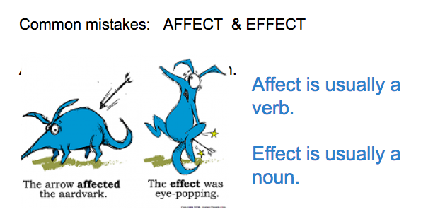

Think about your reading of “The Sniper”.

Write 1 sentence using AFFECT and 1 sentence using EFFECT. Both sentences must relate to last night’s reading.

