Animal Farm Group Activity

Working with your barnyard animal group, complete the following activities. Submit in a Google Slide presentation, and share your presentation with Mrs. Greenlaw.

- 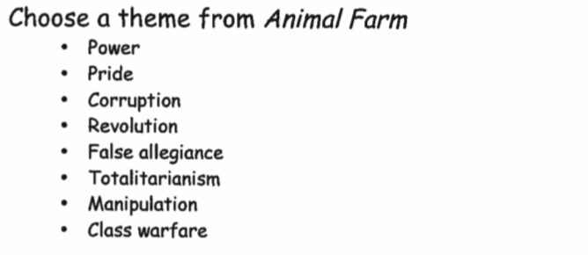
(The theme topics above are examples, but you can also choose another that is not on the list. Do NOT ask Mrs. Greenlaw if your theme topic matches the book. Instead, ask yourself: “Can we support this with evidence from the text?”)
- Slide One: Theme Topic Choice with a picture AND first and last names of all group members.
- Slide Two: Theme Topic written into a THEME STATEMENT about the novel.
- Slide Three: One paragraph explaining HOW the theme relates to the novel. Include at least one piece of text evidence that supports your claim. Be sure to use parenthetical
citation.
- Slide Four: Screen Shot of ONE of the following: news article / current event, song lyrics, poem, art piece.
- Slide Five: One paragraph explaining HOW the item in slide four relates to the theme / novel. Although helpful, no textual evidence is required for this paragraph, just two reasons why it relates AND discussion.

Slide presentation is due at the end of class. Divide the work up between group members.

Don’t forget to proofread!

