Appropriation Art with Drama
An Independent Study during SSR

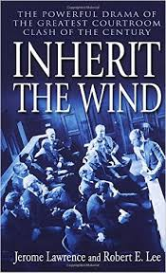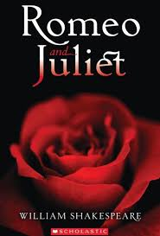

Students will read and study their choice of ONE of the following dramas during SSR: either Inherit the Wind by Jerome Lawrence and Robert E. Lee or Romeo and Juliet by William Shakespeare.

Students will have 20 minutes per day during SSR for 3 weeks beginning April 10th for reading. Reading of the dramas should be completed by Friday, April 28th.

On Friday, April 28th, we will have a lesson on Black Out Poetry (Appropriation Art).

Each Friday, beginning April 28th and for 4 Fridays thereafter, approximately 8 students will take home our Appropriation Art books to complete their projects. The schedule is listed below. Students have the weekend, Monday, and Tuesday to complete their project. Project is due on WEDNESDAY. All students will present their projects to the class. Teacher will have 2 days to grade the projects and then on Friday another 8 students will take the books home for their projects.

Week 1 (April 28th)…Project due on Wednesday, May 3rd
1. JT Bowen
2. Sheridan Fenner
3. Hayden Hanna
4. Tanvi Khanduri
5. Jaidyn Munoz
6. Jacob Price
7. Kitty Twichell

Week 2 (May 5th)…Project due on Wednesday, May 10th
1. Tyler Bowen
2. Alana Brown
3. Gavin Hill
4. Paige Larue
5. Courtney Parnitke
6. Jason Ragsdale
7. Matthew Storrie
8. Andrew Vazquez

Week 3 (May 12th)…Project due on Wednesday, May 17th
1. Levi Briggs
2. Rohan Gaikwad
3. Austin James
4. Maddie Lloyd
5. Michelle Pavlik
6. Sabrina Ricci
7. Connor Thompson
8. Jenna Webb

Week 4 (May 19th)…Project due on Wednesday, May 24th
1. Brendan Ford
2. Jacob Galloway
3. Ally Joven
4. Hope Lowden
5. Destiny Paxton
6. Selena Sheth

REQUIREMENTS:
- The focus of the Black Out Poetry should be “AUTHOR’s PURPOSE/MESSAGE”.
- Black Out Poem should span 2 pages
- Black Out Poem should include art as well as poetry.
- Black Out Poem should include a clear path.
- Black Out Poem should read in complete thoughts and be at least 3 lines long.
- You will paste an analysis on the two pages following the appropriation art. This analysis will relate your appropriation art to the drama (a typed, lengthy paragraph with your name on it).
- The analysis must include TEXT EVIDENCE from both the appropriation art AND the drama. Correct parenthetical citation must be included.

