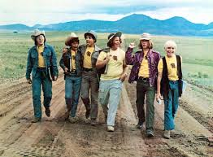

Reading Schedule for Bless the Beasts and Children

Read these chapters by this date:

1-3 2/6
4&5 2/8
6-8 2/11
9&10 2/12
11 2/13
12&13 2/14
14&15 2/15
16-18 2/19
19&20 2/20

Pre-AP English I students will be expected to come to class prepared, having read the chapters and made annotations throughout their reading. Writing, discussion, and other activities will take place in class to further our depth of understanding of the novel, and students will be encouraged to share ideas and participate in literary criticism.

When annotating, students should keep the following questions in mind:

- What is/are the theme(s) of Bless the Beasts and Children?

- What literary techniques does Glendon Swarthout use to convey the theme of his novel?

and

- How do the discussions from Thomas C. Foster’s novel, How to Read Literature Like a Professor for Kids, relate specifically to Bless the Beasts and Children?

