Unit 1 Authentic Assessment for Perspective Unit
What does it mean to play devil’s advocate? One plays devil’s advocate when one argues against a cause or position either for the sake of argument or to help determine its validity.

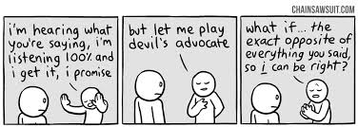

Objectives: During this unit, we have studied multiple perspectives on different topics, often synthesizing many genres of writing on a similar theme. We have also worked on the skill of annotating for relevance, embedding quotes and citing sources correctly. Your goal will be to question yourself as a reader and a writer as you choose a controversial issue, start a blog, differentiate between claims that are substantiated and non-substantiated, write an argument to a controversial issue of your choice, and respond to a classmate’s argument writing by playing devil’s advocate and practicing diplomacy and tact.

Students will:

- Create a Weebly site with the following: Home page, About Me, and a Blog. Once your Weebly is set up, email the link to your site to greenlawa@lisd.net .
- Select a controversial issue from the list of “301 Prompts for Argumentative Writing.”
- Respond to the topic of your choice in a 5-paragraph format: introduction, 3 body paragraphs, and conclusion. Don’t forget to add a creative title when you are finished!
- Research your topic and find sources to back up your stance. Include at least 1 embedded quote with proper citation per body paragraph.
- Compose a Works Cited page with a minimum of 3 sources. This is to be written directly underneath your essay.
- Students will then draw numbers and be assigned another student’s blog post. This is the blog/topic where you will play Devil’s Advocate.
- You will repeat steps C, D, and E, but this time you will post your writing as a comment on your classmate’s blog.

