Dystopian Society Descriptions

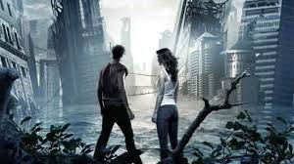

After writing a hypothesis, each Guardian of the Galaxy Group will need to provide a thorough description of their dystopian society. This should first be planned out in the form of a rough draft by answering a series of question and then put together in a formal presentation through Adobe Spark.

Use the following as a guideline for questions to answer. However, there are other items you may wish to include.

* What was the society like before the problem?
* What is the society problem you are focusing on?
* What year is it? How many years are you predicting it takes for our society to become a dystopian society where this problem becomes totally out of control?
* How does the problem affect the population (physical and emotional well-being, social)? Environment (plants, animals, atmosphere, and man-made structures)? Economics?

You should include both graphics and voice in your society description.

