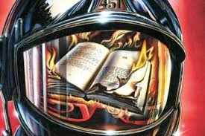

Reading Schedule for Fahrenheit 451

Read this section by this date:

Part I Feb. 6

Part II Feb. 12

Part III Feb. 20

GT Pre AP English I students will be expected to come to class prepared, having read the chapters and made annotations throughout their reading. Writing, discussion, and other activities will take place in class to further our depth of understanding of the novel, and students will be encouraged to share ideas and participate in literary criticism.

When annotating, students should keep the following questions in mind:

- What is/are the theme(s) of Fahrenheit 451?

- What literary techniques does Ray Bradbury use to convey the theme of his novel?

- Why might someone use this novel to call Bradbury a visionary?

and

- How do the discussions from Thomas C. Foster’s novel, How to Read Literature Like a Professor for Kids, relate specifically to Fahrenheit 451?

