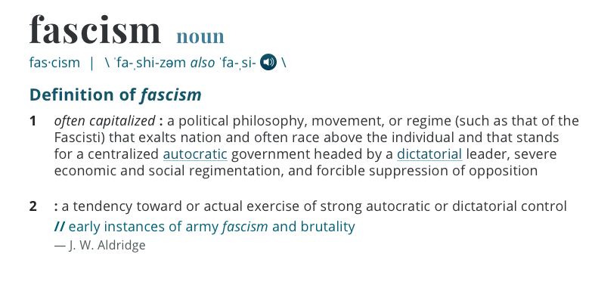

Journal/ discussion: How are the events that unfold in both The Wave and Animal Farm examples of fascism? Use specific examples from the texts to support your claim.

