Fixed vs. Growth: The Two Basic Mindsets That Shape Our Lives
How to fine-tune the internal monologue that scores every aspect of our lives, from leadership to love.
BY MARIA POPOVA
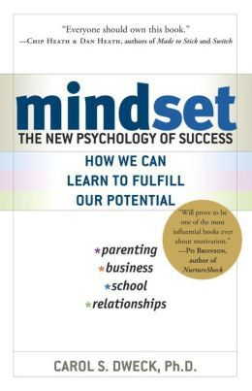
“If you imagine less, less will be what you undoubtedly deserve,” Debbie Millman counseled in one of the best commencement speeches ever given, urging: “Do what you love, and don’t stop until you get what you love. Work as hard as you can, imagine immensities…” Far from Pollyanna platitude, this advice actually reflects what modern psychology knows about how belief systems about our own abilities and potential fuel our behavior and predict our success. Much of that understanding stems from the work of Stanford psychologist Carol Dweck, synthesized in her remarkably insightful Mindset: The New Psychology of Success (public library) — an inquiry into the power of our beliefs, both conscious and unconscious, and how changing even the simplest of them can have profound impact on nearly every aspect of our lives.
One of the most basic beliefs we carry about ourselves, Dweck found in her research, has to do with how we view and inhabit what we consider to be our personality. A “fixed mindset” assumes that our character, intelligence, and creative ability are static givens which we can’t change in any meaningful way, and success is the affirmation of that inherent intelligence, an assessment of how those givens measure up against an equally fixed standard; striving for success and avoiding failure at all costs become a way of maintaining the sense of being smart or skilled. A “growth mindset,” on the other hand, thrives on challenge and sees failure not as evidence of unintelligence but as a heartening springboard for growth and for stretching our existing abilities. Out of these two mindsets, which we manifest from a very early age, springs a great deal of our behavior, our relationship with success and failure in both professional and personal contexts, and ultimately our capacity for happiness.
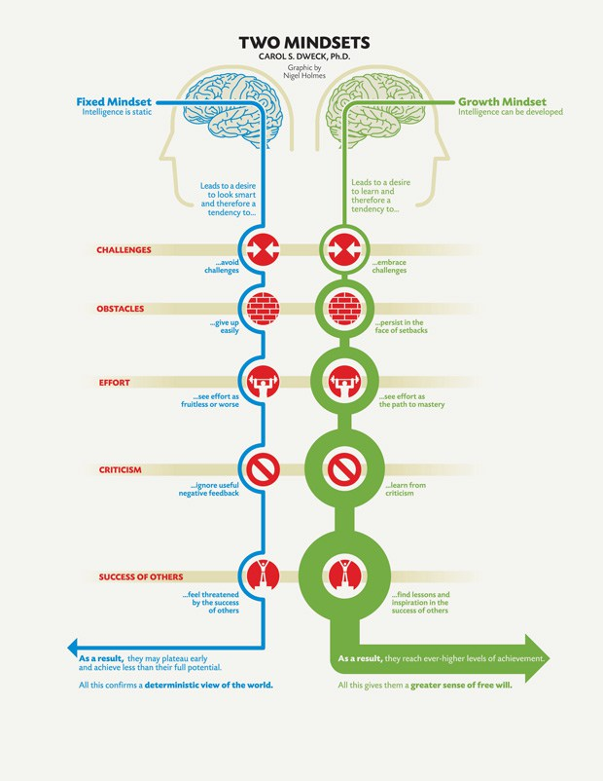
The consequences of believing that intelligence and personality can be developed rather than being immutably engrained traits, Dweck found in her two decades of research with both children and adults, are remarkable. She writes:
For twenty years, my research has shown that the view you adopt for yourself profoundly affects the way you lead your life. It can determine whether you become the person you want to be and whether you accomplish the things you value. How does this happen? How can a simple belief have the power to transform your psychology and, as a result, your life?
Believing that your qualities are carved in stone — the fixed mindset — creates an urgency to prove yourself over and over. If you have only a certain amount of intelligence, a certain personality, and a certain moral character — well, then you’d better prove that you have a healthy dose of them. It simply wouldn’t do to look or feel deficient in these most basic characteristics.
[…]
I’ve seen so many people with this one consuming goal of proving themselves — in the classroom, in their careers, and in their relationships. Every situation calls for a confirmation of their intelligence, personality, or character. Every situation is evaluated: Will I succeed or fail? Will I look smart or dumb? Will I be accepted or rejected? Will I feel like a winner or a loser? . . .
There’s another mindset in which these traits are not simply a hand you’re dealt and have to live with, always trying to convince yourself and others that you have a royal flush when you’re secretly worried it’s a pair of tens. In this mindset, the hand you’re dealt is just the starting point for development. This growth mindset is based on the belief that your basic qualities are things you can cultivate through your efforts. Although people may differ in every which way — in their initial talents and aptitudes, interests, or temperaments — everyone can change and grow through application and experience.
Do people with this mindset believe that anyone can be anything, that anyone with proper motivation or education can become Einstein or Beethoven? No, but they believe that a person’s true potential is unknown (and unknowable); that it’s impossible to foresee what can be accomplished with years of passion, toil, and training.
At the heart of what makes the “growth mindset” so winsome, Dweck found, is that it creates a passion for learning rather than a hunger for approval. Its hallmark is the conviction that human qualities like intelligence and creativity, and even relational capacities like love and friendship, can be cultivated through effort and deliberate practice. Not only are people with this mindset not discouraged by failure, but they don’t actually see themselves as failing in those situations — they see themselves as learning. Dweck writes:
Why waste time proving over and over how great you are, when you could be getting better? Why hide deficiencies instead of overcoming them? Why look for friends or partners who will just shore up your self-esteem instead of ones who will also challenge you to grow? And why seek out the tried and true, instead of experiences that will stretch you? The passion for stretching yourself and sticking to it, even (or especially) when it’s not going well, is the hallmark of the growth mindset. This is the mindset that allows people to thrive during some of the most challenging times in their lives.
This idea, of course, isn’t new — if anything, it’s the fodder of self-help books and vacant “You can do anything!” platitudes. What makes Dweck’s work different, however, is that it is rooted in rigorous research on how the mind — especially the developing mind — works, identifying not only the core drivers of those mindsets but also how they can be reprogrammed.
Dweck and her team found that people with the fixed mindset see risk and effort as potential giveaways of their inadequacies, revealing that they come up short in some way. But the relationship between mindset and effort is a two-way street:
It’s not just that some people happen to recognize the value of challenging themselves and the importance of effort. Our research has shown that this comes directly from the growth mindset. When we teach people the growth mindset, with its focus on development, these ideas about challenge and effort follow. . . .
As you begin to understand the fixed and growth mindsets, you will see exactly how one thing leads to another—how a belief that your qualities are carved in stone leads to a host of thoughts and actions, and how a belief that your qualities can be cultivated leads to a host of different thoughts and actions, taking you down an entirely different road.
[…]
The mindsets change what people strive for and what they see as success. . . they change the definition, significance, and impact of failure. . . they change the deepest meaning of effort.
Dweck cites a poll of 143 creativity researchers, who concurred that the number-one trait underpinning creative achievement is precisely the kind of resilience and fail-forward perseverance attributed to the growth mindset. She writes:
When you enter a mindset, you enter a new world. In one world — the world of fixed traits — success is about proving you’re smart or talented. Validating yourself. In the other — the world of changing qualities — it’s about stretching yourself to learn something new. Developing yourself.
In one world, failure is about having a setback. Getting a bad grade. Losing a tournament. Getting fired. Getting rejected. It means you’re not smart or talented. In the other world, failure is about not growing. Not reaching for the things you value. It means you’re not fulfilling your potential.
In one world, effort is a bad thing. It, like failure, means you’re not smart or talented. If you were, you wouldn’t need effort. In the other world, effort is what makes you smart or talented.
But her most remarkable research, which has informed present theories of why presence is more important than praise in teaching children to cultivate a healthy relationship with achievement, explores how these mindsets are born — they form, it turns out, very early in life. In one seminal study, Dweck and her colleagues offered four-year-olds a choice: They could either redo an easy jigsaw puzzle, or try a harder one. Even these young children conformed to the characteristics of one of the two mindsets — those with “fixed” mentality stayed on the safe side, choosing the easier puzzles that would affirm their existing ability, articulating to the researchers their belief that smart kids don’t make mistakes; those with the “growth” mindset thought it an odd choice to begin with, perplexed why anyone would want to do the same puzzle over and over if they aren’t learning anything new. In other words, the fixed-mindset kids wanted to make sure they succeeded in order to seem smart, whereas the growth-mindset ones wanted to stretch themselves, for their definition of success was about becoming smarter.
Dweck quotes one seventh-grade girl, who captured the difference beautifully:
I think intelligence is something you have to work for … it isn’t just given to you.… Most kids, if they’re not sure of an answer, will not raise their hand to answer the question. But what I usually do is raise my hand, because if I’m wrong, then my mistake will be corrected. Or I will raise my hand and say, ‘How would this be solved?’ or ‘I don’t get this. Can you help me?’ Just by doing that I’m increasing my intelligence.
Things got even more interesting when Dweck brought people into Columbia’s brain-wave lab to study how their brains behaved as they answered difficult questions and received feedback. What she found was that those with a fixed mindset were only interested in hearing feedback that reflected directly on their present ability, but tuned out information that could help them learn and improve. They even showed no interest in hearing the right answer when they had gotten a question wrong, because they had already filed it away in the failure category. Those with a growth mindset, on the other hand, were keenly attentive to information that could help them expand their existing knowledge and skill, regardless of whether they’d gotten the question right or wrong — in other words, their priority was learning, not the binary trap of success and failure.
These findings are especially important in education and how we, as a culture, assess intelligence. In another study of hundreds of students, mostly adolescents, Dweck and her colleagues gave each ten fairly challenging problems from a nonverbal IQ test, then praised the student for his or her performance — most had done pretty well. But they offered two types of praise: Some students were told “Wow, you got [X many] right. That’s a really good score. You must be smart at this,” while others, “Wow, you got [X many] right. That’s a really good score. You must have worked really hard.” In other words, some were praised for ability and others for effort. The findings, at this point, are unsurprising yet jarring:
The ability praise pushed students right into the fixed mindset, and they showed all the signs of it, too: When we gave them a choice, they rejected a challenging new task that they could learn from. They didn’t want to do anything that could expose their flaws and call into question their talent.
[…]
In contrast, when students were praised for effort, 90 percent of them wanted the challenging new task that they could learn from.
The most interesting part, however, is what happened next: When Dweck and her colleagues gave the students a subsequent set of harder problems, on which the students didn’t do so well. Suddenly, the ability-praised kids thought they weren’t so smart or gifted after all. Dweck puts it poignantly:
If success had meant they were intelligent, then less-than-success meant they were deficient.
But for the effort-praised kids, the difficulty was simply an indication that they had to put in more effort, not a sign of failure or a reflection of their poor intellect. Perhaps most importantly, the two mindsets also impacted the kids’ level of enjoyment — everyone enjoyed the first round of easier questions, which most kids got right, but as soon as the questions got more challenging, the ability-praised kids no longer had any fun, while the effort-praised ones not only still enjoyed the problems but even said that the more challenging, the more fun. The latter also had significant improvements in their performance as the problems got harder, while the former kept getting worse and worse, as if discouraged by their own success-or-failure mindset.
It gets better — or worse, depending on how we look at it: The most unsettling finding came after the IQ questions were completed, when the researchers asked the kids to write private letters to their peers relaying the experience, including a space for reporting their scores on the problems. To Dweck’s devastation, the most toxic byproduct of the fixed mindset turned out to be dishonesty: Forty percent of the ability-praised kids lied about their scores, inflating them to look more successful. She laments:
In the fixed mindset, imperfections are shameful — especially if you’re talented — so they lied them away. What’s so alarming is that we took ordinary children and made them into liars, simply by telling them they were smart.
This illustrates the key difference between the two mindsets — for those with a growth one, “personal success is when you work your hardest to become your best,” whereas for those with a fixed one, “success is about establishing their superiority, pure and simple. Being that somebody who is worthier than the nobodies.” For the latter, setbacks are a sentence and a label. For the former, they’re motivating, informative input — a wakeup call.
But one of the most profound applications of this insight has to do not with business or education but with love. Dweck found that people exhibited the same dichotomy of dispositions in their personal relationships: Those with a fixed mindset believed their ideal mate would put them on a pedestal and make them feel perfect, like “the god of a one-person religion,” whereas those with the growth mindset preferred a partner who would recognize their faults and lovingly help improve them, someone who would encourage them to learn new things and became a better person. The fixed mindset, it turns out, is at the root of many of our most toxic cultural myths about “true love.” Dweck writes:
The growth mindset says all of these things can be developed. All — you, your partner, and the relationship — are capable of growth and change.
In the fixed mindset, the ideal is instant, perfect, and perpetual compatibility. Like it was meant to be. Like riding off into the sunset. Like “they lived happily ever after.”
[…]
One problem is that people with the fixed mindset expect everything good to happen automatically. It’s not that the partners will work to help each other solve their problems or gain skills. It’s that this will magically occur through their love, sort of the way it happened to Sleeping Beauty, whose coma was cured by her prince’s kiss, or to Cinderella, whose miserable life was suddenly transformed by her prince.
This also applies to the myth of mind-reading, where the fixed mindset believes that an ideal couple should be able to read each other’s minds and finish each other’s sentences. She cites a study that invited people to talk about their relationships:
Those with the fixed mindset felt threatened and hostile after talking about even minor discrepancies in how they and their partner saw their relationship. Even a minor discrepancy threatened their belief that they shared all of each other’s views.
But most destructive of all relationship myths is the belief that if it requires work, something is terribly wrong and that any discrepancy of opinions or preferences is indicative of character flaws on behalf of one’s partner. Dweck offers a reality check:
Just as there are no great achievements without setbacks, there are no great relationships without conflicts and problems along the way.
When people with a fixed mindset talk about their conflicts, they assign blame. Sometimes they blame themselves, but often they blame their partner. And they assign blame to a trait — a character flaw.
But it doesn’t end there. When people blame their partner’s personality for the problem, they feel anger and disgust toward them.
And it barrels on: Since the problem comes from fixed traits, it can’t be solved. So once people with the fixed mindset see flaws in their partners, they become contemptuous of them and dissatisfied with the whole relationship.
Those with the growth mindset, on the other hand, can acknowledge their partners’ imperfections, without assigning blame, and still feel that they have a fulfilling relationship. They see conflicts as problems of communication, not of personality or character. This dynamic holds true as much in romantic partnerships as in friendship and even in people’s relationships with their parents. Dweck summarizes her findings:
When people embark on a relationship, they encounter a partner who is different from them, and they haven’t learned how to deal with the differences. In a good relationship, people develop these skills and, as they do, both partners grow and the relationship deepens. But for this to happen, people need to feel they’re on the same side. . . . As an atmosphere of trust developed, they [become] vitally interested in each other’s development.
What it all comes down to is that a mindset is an interpretative process that tells us what is going on around us. In the fixed mindset, that process is scored by an internal monologue of constant judging and evaluation, using every piece of information as evidence either for or against such assessments as whether you’re a good person, whether your partner is selfish, or whether you are better than the person next to you. In a growth mindset, on the other hand, the internal monologue is not one of judgment but one of voracious appetite for learning, constantly seeking out the kind of input that you can metabolize into learning and constructive action.
In the rest of Mindset: The New Psychology of Success, Dweck goes on to explore how these fundamental mindsets form, what their defining characteristics are in different contexts of life, and how we can rewire our cognitive habits to adopt the much more fruitful and nourishing growth mindset.
Public domain photographs via Flickr Commons
END posts

