Formative Assessment: Look at the sentences below and classify each one as a
OR a
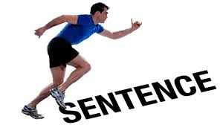 .

Label F for Fragment and RO for Run-On Sentence.

____________ 1. I got up at four in the morning and the world was still asleep.

____________ 2. Because he was scared.

____________ 3. I woke up, I ate breakfast.

____________ 4. The bear scared the campers he was tall and hairy.

____________ 5. A movie of a mysterious land with a man on a quest.

Next. Re-write each one on the N2K side of your Writer’s Notebook. Use the header “Fragment and Run-On Corrections.” On the run-ons, practice correcting at least one of them by joining the two complete thoughts like we have learned in our N2Ks and some with a new method. A semi-colon! See the example below:

Run-On: You’re about halfway through this exercise you should be smarter by now.

Correction: You’re about halfway through this exercise; you should be smarter by now.

