Is Brother Guilty or Innocent?
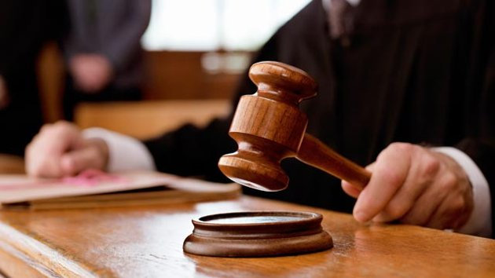

Take a second look at the story and find either 3 pieces of text evidence that support that Brother is guilty of the murder of his brother, Doodle, or three pieces of text evidence that support that Brother is innocent. What is your opinion?

I believe that Brother is ___________________________.

Evidence 1:

This supports my belief how?

Evidence 2:

This supports my belief how?

Evidence 3:

This supports my belief how?

