The Scopes Trial

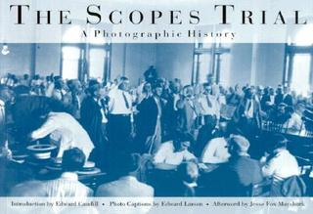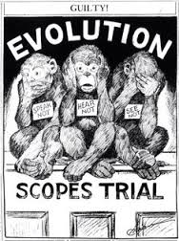

The Scopes Trial, formally known as The State of Tennessee v. John Thomas Scopes and commonly referred to as the Scopes Monkey Trial, was an American legal case in May 1925 in which a substitute high school teacher, John T. Scopes, was accused of violating Tennessee's Butler Act, which had made it unlawful to teach human evolution in any state-funded school. The trial was deliberately staged in order to attract publicity to the small town of Dayton, Tennessee, where it was held. Scopes was unsure whether he had ever actually taught evolution, but he purposely incriminated himself so that the case could have a defendant.
Scopes was found guilty and fined $100 ($1366 in 2016), but the verdict was overturned on a technicality. The trial served its purpose of drawing intense national publicity, as national reporters flocked to Dayton to cover the big-name lawyers who had agreed to represent each side. William Jennings Bryan, three-time presidential candidate, argued for the prosecution, while Clarence Darrow, the famed defense attorney, spoke for Scopes. The trial publicized the Fundamentalist–Modernist Controversy, which set Modernists, who said evolution was not inconsistent with religion, against Fundamentalists, who said the word of God as revealed in the Bible took priority over all human knowledge. The case was thus seen as both a theological contest and a trial on whether "modern science" should be taught in schools.

