Is Brother Guilty or Innocent?
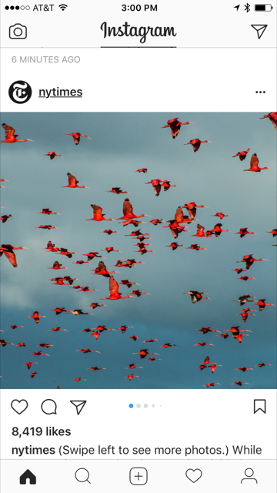

Readers have mixed feelings when it comes to discussing Brother’s responsibility for the death of Doodle. Your job is to evaluate the facts in the story and your response to them. You need to choose a side and gather evidence from the text to support your stance on whether you feel Brother is guilty of innocent.

- Fill out a Guilty or Innocent fact sheet by gathering evidence from the text.
- Pretend you are either a prosecuting or defense attorney and compose a one paragraph opening argument for a trial that incorporates the text evidence you pulled from the story.
- Begin your paragraph with the following:
Your honor and members of the jury, my name is ____________________, and I am here today to present to you facts that prove Brother is _____________________________ for the death of William Armstrong, otherwise known as Doodle.
- Make sure you use transitions when you switch from one piece of evidence to the next.
- Use the “How to Write an Opening Argument” document for information on how to stick to the facts and not include personal bias. It will also help you with including formal, courtroom language.

