It’s All about the Journey, Not the Destination

Life is a journey. Of course, you have heard this statement before—it’s something of a cliché. But take a moment to think about your own life. Have you “arrived” at your final destination?
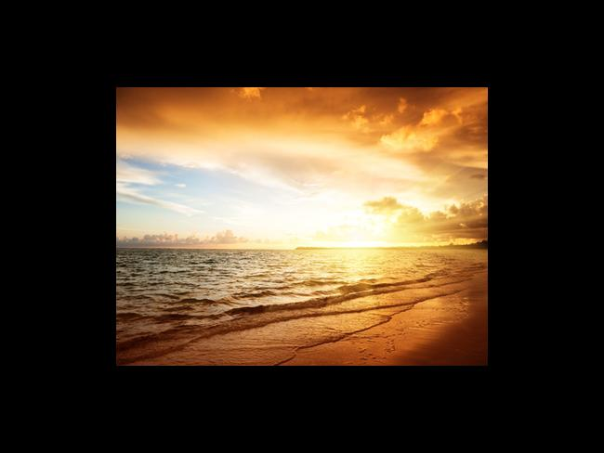
Life is a journey. Of course, you have heard this statement before—it’s something of a cliché. But take a moment to think about your own life. Have you “arrived” at your final destination? Have you achieved everything you’ve hoped to achieve? Traveled everywhere you’ve wanted to visit? Finished everything you’ve wanted to complete?
I’m willing to bet that the answer to all of these questions is “no”!
The truth is, no matter how much you achieve, accomplish, and acquire in life… there is always something more to be had. You’ll never “reach” your final destination—at least not in this life!
So, why does all this matter? Because far too many people put off what really matters in pursuit of the things they want to achieve. They tell themselves that they’ll worry about these things once they’ve reached their destination.
Things like family. Enjoying friends. Nurturing relationships. Forgiving enemies. Enjoying life. Experiencing peace. These things are put off… and most of the time, they are never re-discovered.
However, the key to obtaining real peace in our lives is to focus on enjoying the journey, taking the time to “smell the roses,” and focusing on what’s really important in life. This doesn’t mean that we have to give up on our dreams and our goals. It’s good to be ambitious; it’s great to want to accomplish enormous things in our life. The key, however, is simply finding the right balance, discovering a mindset that allows us to pursue big things without sacrificing the “little things” that make life worth living.
Here’s a simple exercise for you. Take out a sheet of paper and jot down three of your biggest “life goals”. These should be significant milestones… such as “buying my dream home,” “finding my perfect soul mate, ” “writing a best-selling book,” etc. Now, on a separate section of the sheet, write down 5-10 of the most important “little things” that you don’t want to forget about as you work towards these goals. Things such as: “time with my daughter/son/significant other,” “nurturing relationships with friends,” “plenty of free time,” etc. When you’ve finished this exercise, place this sheet of paper in a safe place. You will have created a visual reminder that will help you with one of life’s biggest challenges: enjoying the journey in life, instead of focusing obsessively on reaching your final destination.

Sure, it’s great to focus on destinations, but the most important thing is that you learn to be happy — right here and now. I know this will be life changing for you, and also for all those in your life!
Many blessings to you!
----------------------------------------
Karen Noé is a renowned NJ based psychic medium, spiritual counselor, and healer with a two-year waiting list. She is the author of The Rainbow Follows the Storm: How to Obtain Inner Peace by Connecting with Angels and Deceased Loved Ones and Through the Eyes of Another: A Medium’s Guide to Creating Heaven on Earth by Encountering Your Life Review Now. Her new book, Your Life After Their Death will be released with Hay House in May of 2014. She is the founder of the Angel Quest Center in Ramsey, NJ where she teaches classes, gives readings, and practices alternative healing. You can listen to Karen on The Angel Quest Radio Show by tuning to www.wrcr.com on the first Saturday of every month at 1:05pm EST. Please visit Karen’s website at www.karennoe.com.

