Journal: When was the last time you did something that scared or challenged you? Why was it scary or challenging?

-OR-

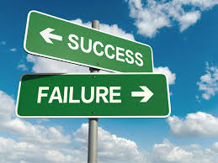

Journal: When have you succeeded when you thought you might fail?

