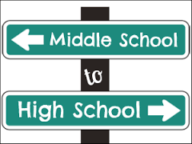

Journal: Think back to when you were in 7th and 8th grade.
What did you THINK high school was going to be like?
Be careful not to write about what you know it is now. Simply focus on what you thought it was going to be like when you were in middle school.

