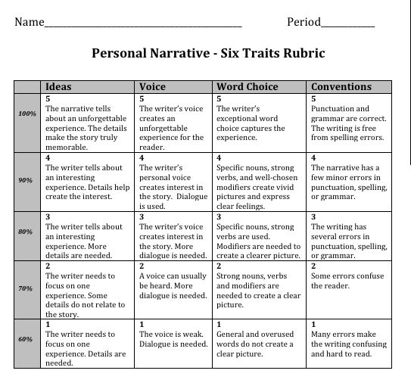

Score: ____________ / 20 = ___________ %

