Option 8 – Checks Written for Monthly Bills

Directions: If you are choosing this writing option for 1 of your 5 writing assessments, write out checks for the following bills. Do them just how we practiced them in class.

- Write out a check for your mortgage.
Date: April 25
Pay: Quicken Loans
Amount: 1,750.00
Write it out: One thousand seven hundred and fifty and no/100
For: mortgage
Sign your name

- Write out a check for groceries.
Date: April 26
Pay: Wal-Mart
Amount: 241.98
Write it out: Two hundred forty-one and no/100
For: groceries
Sign your name

- Write a check for dinner.
Date: April 26
Pay: Ana Mias
Amount: 37.23
Write it out: Thirty-seven and 23/100
For: dinner
Sign your name

- Write a check for your credit card bill.
Date: April 27
Pay: Citibank
Amount: 514.25
Write it out: Five hundred fourteen and 25/100
For: Visa paid in full
Sign your name

- Write a check to Dry Clean Super Center for your dry cleaning.
Date: April 28
Pay: DCSC
Amount: 15.78
Write it out: Fifteen and 78/100
For: dry cleaning
Sign your name

- Write a check for the electric bill.
Date: April 28
Pay: Co-Serv
Amount: 298.00
Write it out: Two hundred ninety-eight and no/100
For: electric
Sign your name

- Write a check for your car payment.
Date: April 28
Pay: Fifth Third Bank
Amount: 347.47
Write it out: Three hundred forty-seven and 47/100
For: car payment
Sign your name

- Write a check for your storage unit rent.
Date: May 1
Pay: Advantage Storage
Amount: 165.00
Write it out: One hundred sixty-five and no/100
For: monthly storage bill
Sign your name

1.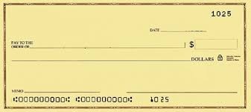

2.

3.

4.

5.

6.

7.

8.

