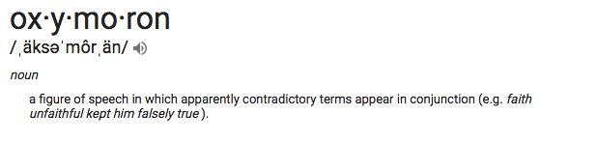
Below is an excerpt from Shakespeare’s play, Romeo and Juliet. Notice the oxymorons used throughout. Highlight the oxymorons you can find.

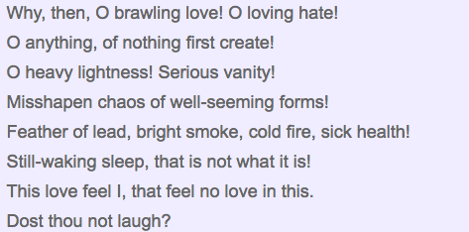

Highlight the oxymorons you can find in the sentences that follow.

- There was a love-hate relationship between the two neighboring states.
- The professor was giving the lecture on virtual reality.
- Paid volunteers were working for the company.
- The channel was repeating the old news again and again.
- The contractor was asked to give the exact estimate of the project.
- A lot of soldiers have been killed in friendly fire.
- The doctor was absolutely unsure of the nature of his illness.
- There was an employee in the office who was regularly irregular.
- The hero of the play was so dejected that he was the perfect embodiment of being alone in a crowd.
- The heads of state gathered to determine an approximate solution to the crisis.
- The green pasture surrounded by hills was teeming with a deafening silence.
- The political scientist was asked to give his unbiased opinion on the current issue.
- The program was not liked by the people, for a lot of unpopular celebrities were invited.

