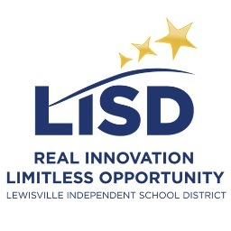
Secondary Literacy and Language Arts
1:X iPad Integration
Annotations, Reading Logs, Collaboration
Grades 6-12

**********
The iPad offers multiple platforms for reading, and the three primary platform readers (iBooks, Nook, and Kindle) all contain features that make annotation, highlighting, and vocabulary inquiry a natural part of the reading experience. All secondary libraries in LISD offer ebooks through the Follett app, and the reader within the app offers similar notation functions. Teachers can provide copies of articles and other resources through PDF files, and various .pdf centered apps allow students to take notes and annotate these texts as well. Perhaps the strongest component of the iPad reading experience is how easy it is to share what you are reading with others—social media apps such as GoodReads allow students to join book clubs, write reviews, participate in discussions, set reading goals, and log their reading.
Resources
iPad iTunes Apps | Examples
e-Readers  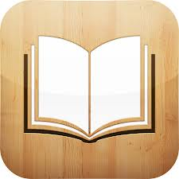  iBooks  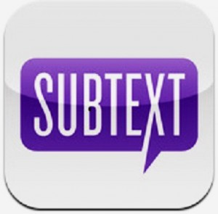  Subtext  Library Resources:  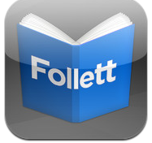  Follett Digital Reader  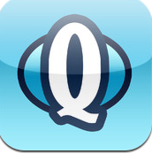  Destiny Quest  PDF Annotations:  i Annotate  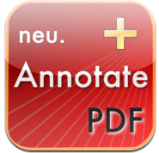  Neu Annotate  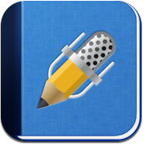  Notability  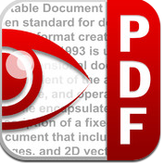  PDF Expert  Responses to Reading:  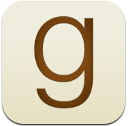  Goodreads  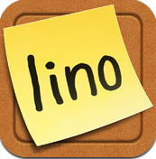  Lino It  Reading Logs:  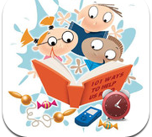  Kids Reading Logs  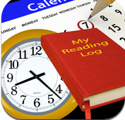  Reading Log  Literary Analysis Aids:  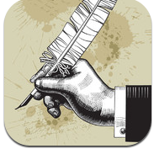  Literary Analysis  Literature Guide | 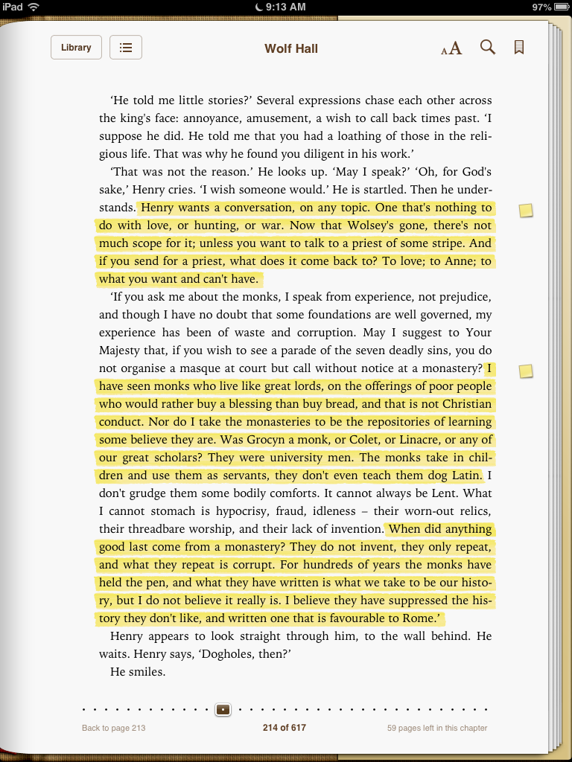  Students can drag their finger across important passages to highlight in the text. After highlighting, students can select the passage and type notes directly into the margin. These highlights and annotations appear in the notes section in the table of contents, along with the date they were entered.  Students can read texts in Subtext, annotate, and answer questions about the text. While in Subtext, students can see annotations from classmates and teachers. Teachers can also upload PDF files to subtexts for students to read and annotate. Subtext can be set up by the teacher on a computer, but requires an iPad to read and annotate material. Subtext can play an audio reading of the text as well as define words and connect to Google Docs.  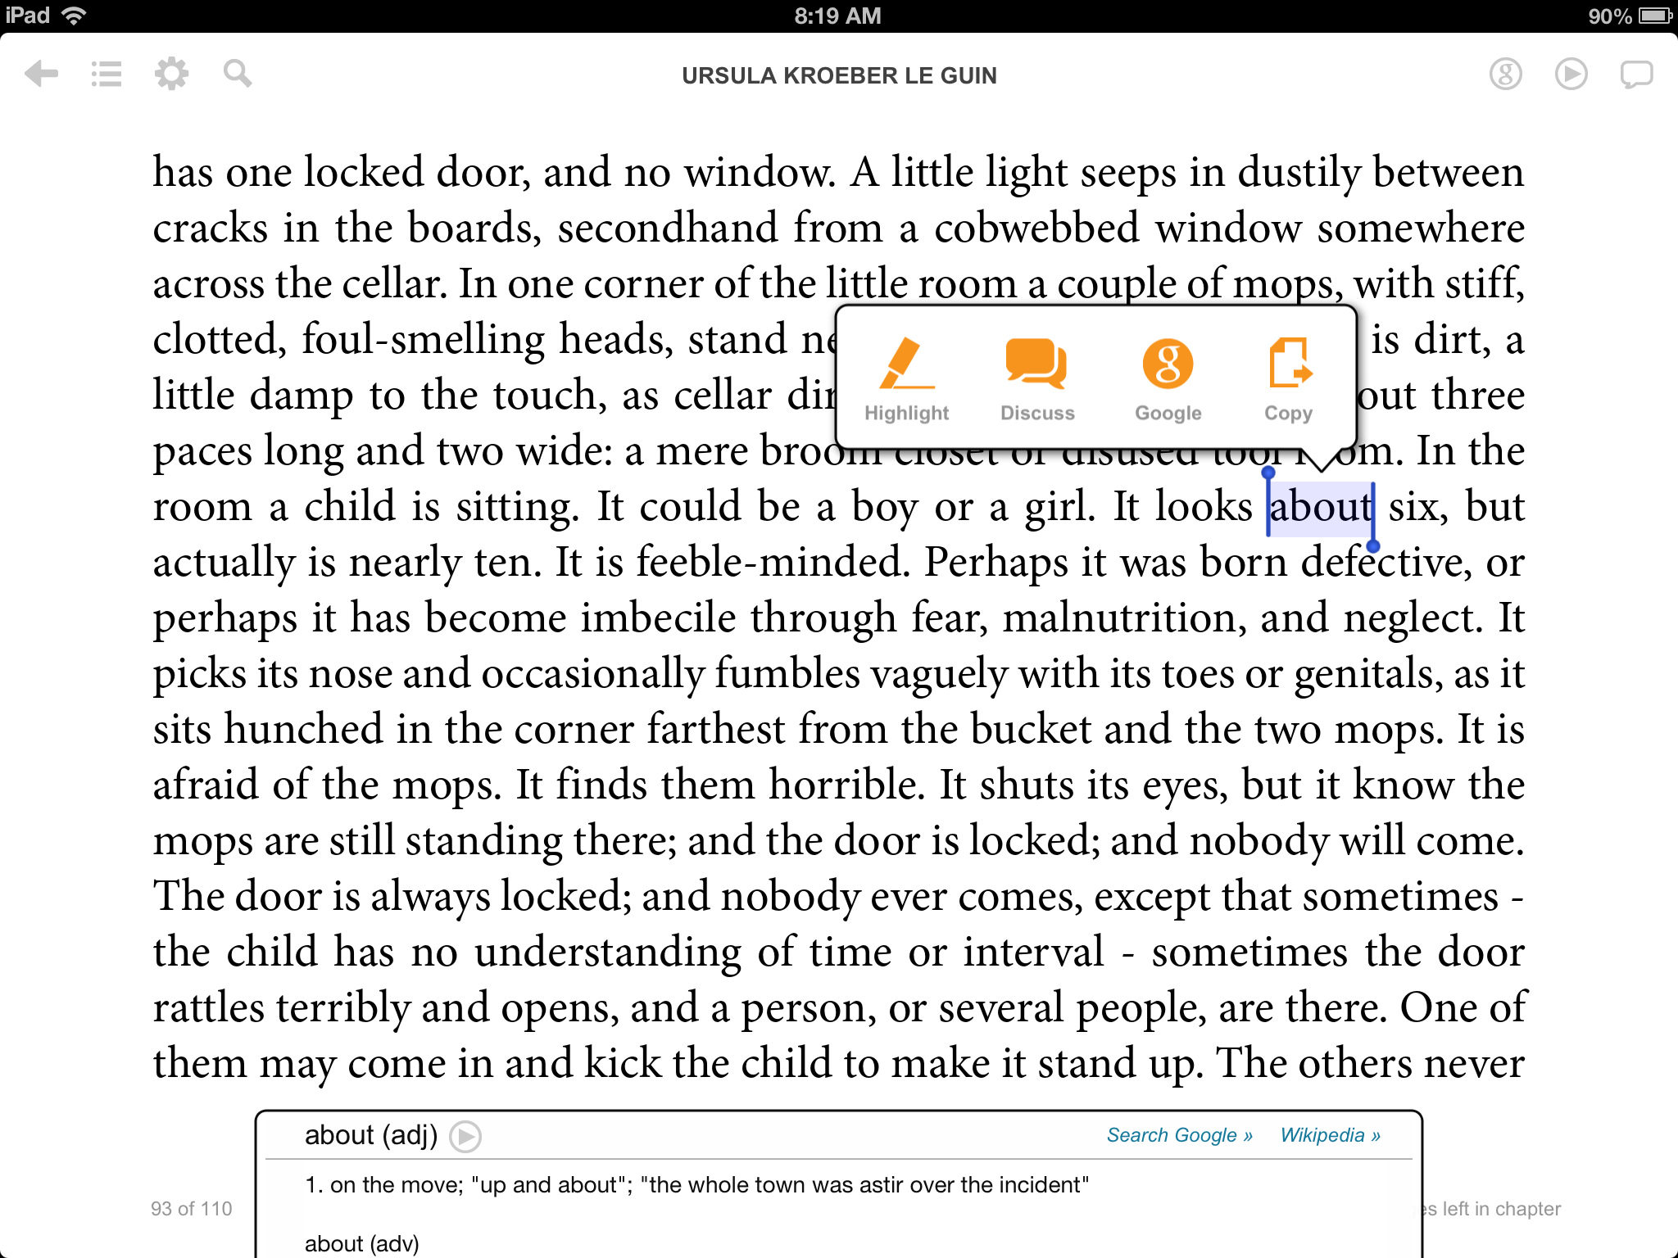  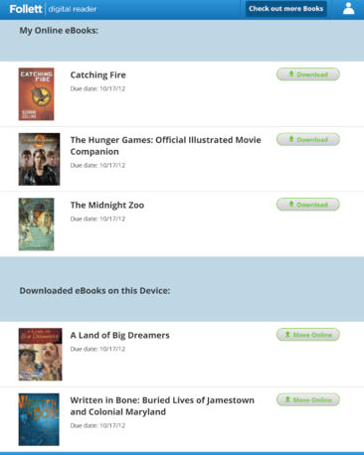  Students can bring the library to their devices with these apps from Follett. Using codes from the library, students can check out, reserve, and search for books. Students can read online and annotate. Students can download the material so they do not need an internet connection to read. At the end of the checkout period, the app removes the book automatically.  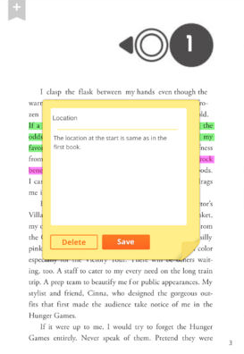  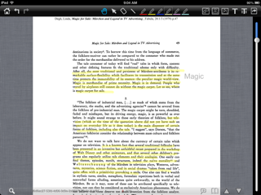  Many apps, including the apps to the side, can provide users the opportunity to annotate documents. While each app has unique features, all allow the user to upload files, annotate, and send the files via email or other device like Evernote back to the user. Most apps allow annotation opportunities that include highlighting in various colors as well as writing in the margins. Some allow users to also place an image in the margin. These apps vary in terms of price, but they occasionally become free for a limited time.  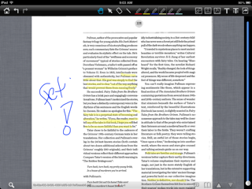  Just like the popular website, the Goodreads app provides students authentic ways to respond to reading. Students can join groups and reading communities, rate books, find books they want to read, and collect favorite quotes. Students can create their own lists and find others who share their reading preferences through the Explore option.  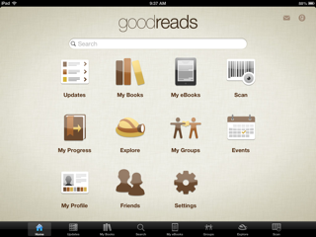  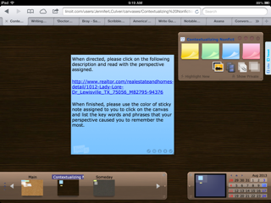  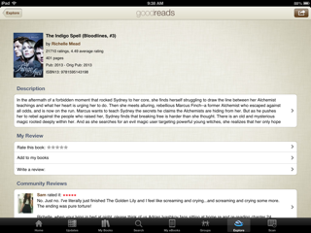  The Lino app provides a user or groups of users to post ideas on a digital corkboard. Using Lino, teachers can post a short text, link, or image, and students can pin notes in the margins responding to the text, asking questions, and making connections. Students can also create a corkboard to showcase original work and receive feedback. Lino also works on a desktop.  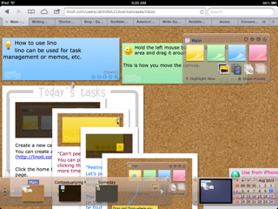  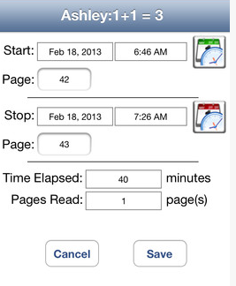  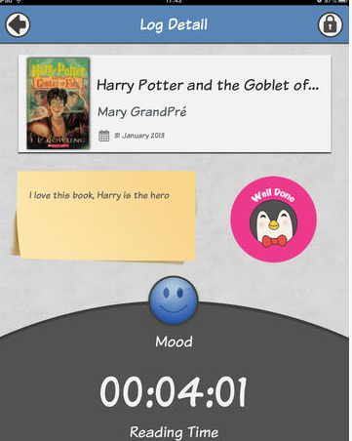  Apps for reading logs can vary some, but most contain the ability for students to record their books and their progress. Some apps include recording time read in each session, pages read in each session, and the ability to track multiple texts for each student. Others also provide an option for students to write details about their reading and summary / review statements at the end of reading their texts.  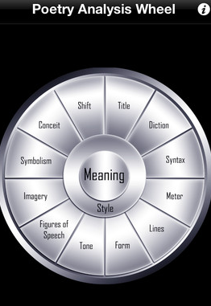  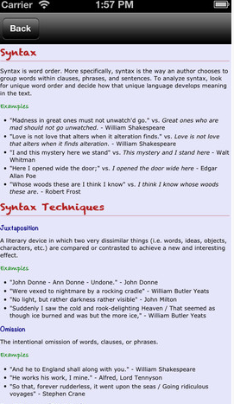  These apps from Gatsby’s help students with literary analysis. Using a wheel, students can choose terms and find definitions, examples from literature, and questions students can ask when considering this term. Literary Guides connects periods of American Literature to the history and art of the same eras, and provides a comprehensive analysis of a piece from each genre.  