Satire:
A literary work that ridicules its subject through the use of techniques such as exaggeration, reversal, incongruity, and/or humour in order to make a comment or criticism about it.

Directions: On a separate sheet of paper, number your questions and answer the following questions. Each answer should be 2 to 3 sentences.
- Identify the satire – what is it about?
- What comment or criticism is the author trying to make?

- 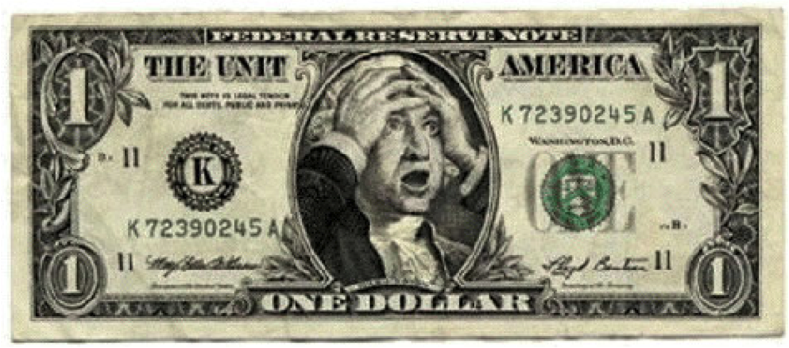

4.
5.

6.

7. 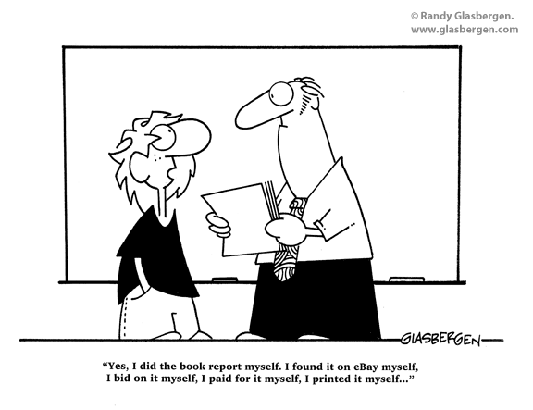

8.

9. 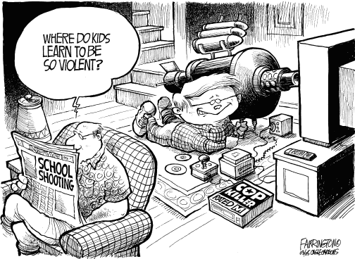

10. 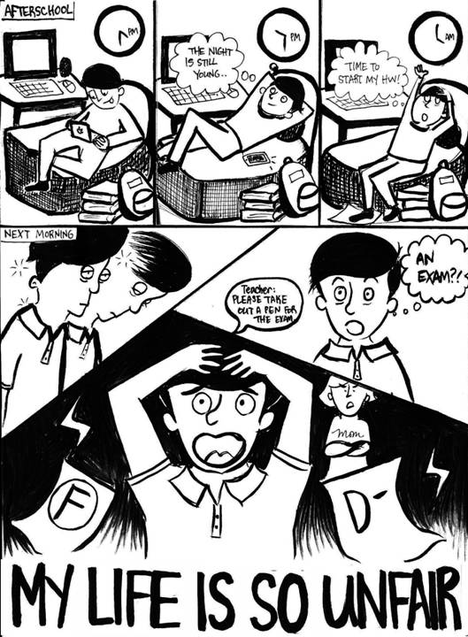

11. +2 Bonus: Write a one paragraph summary about one example from THIS WEEKEND’s Saturday Night Live show. Specifically describe what was being satirized.

