Satire:
A literary work that ridicules its subject through the use of techniques such as exaggeration, reversal, incongruity, and/or humour in order to make a comment or criticism about it.

Directions: On a separate sheet of paper, number your questions and answer the following questions. Each answer should be 2 to 3 sentences.
- Identify the satire – what is it about?
- What comment or criticism is the author trying to make?

- 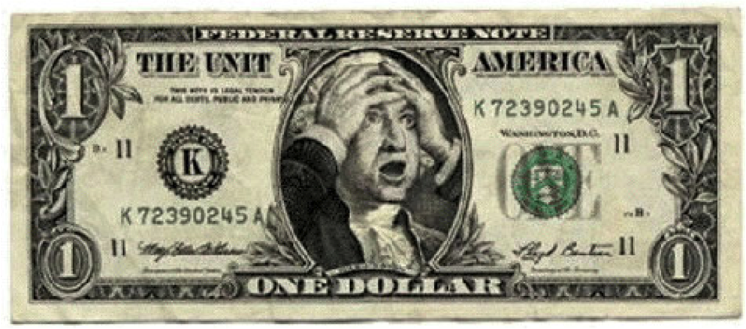

4.
5. 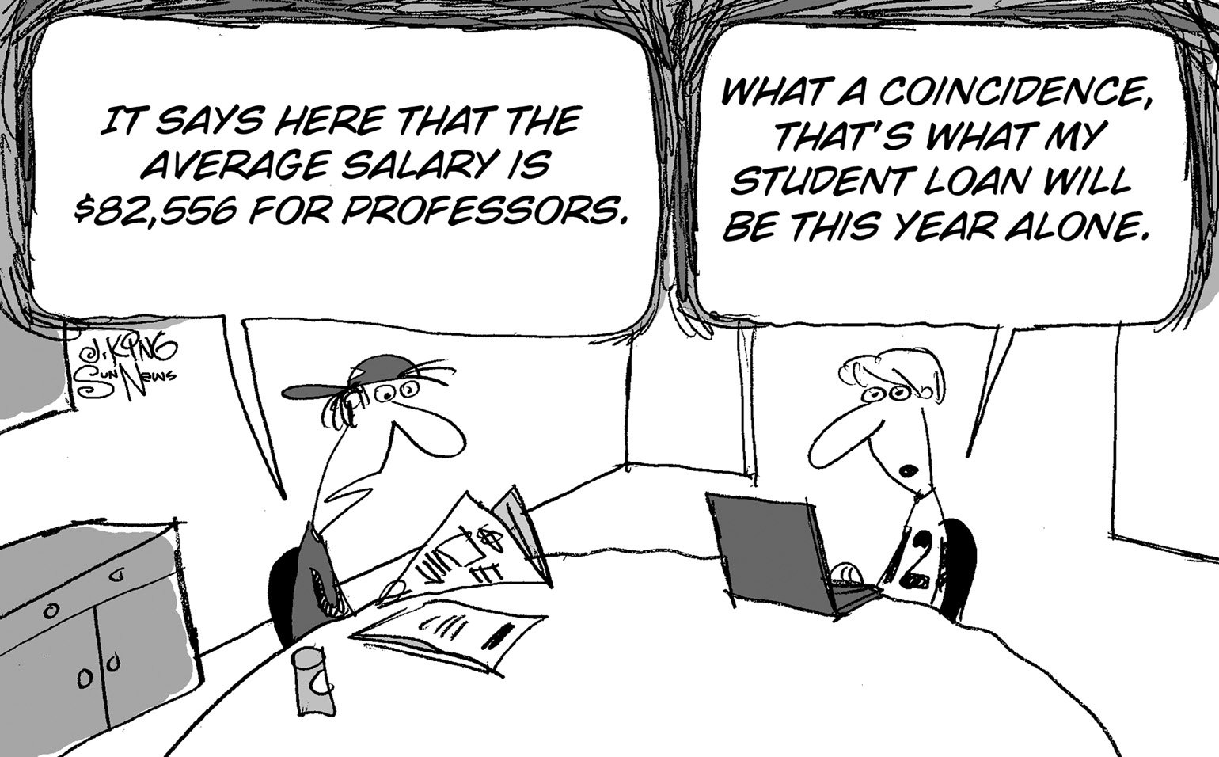

6.

7. 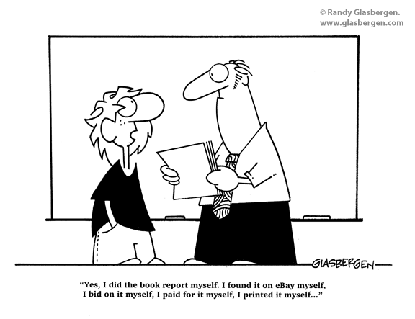

8. 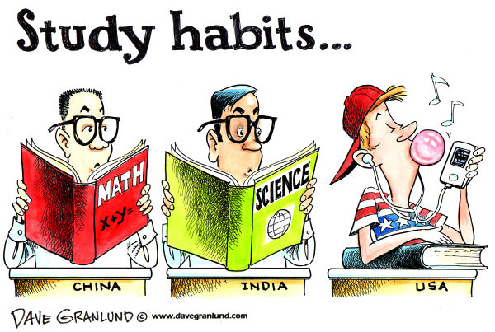

9. 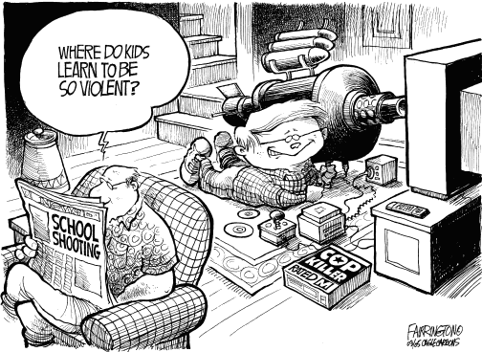

10. 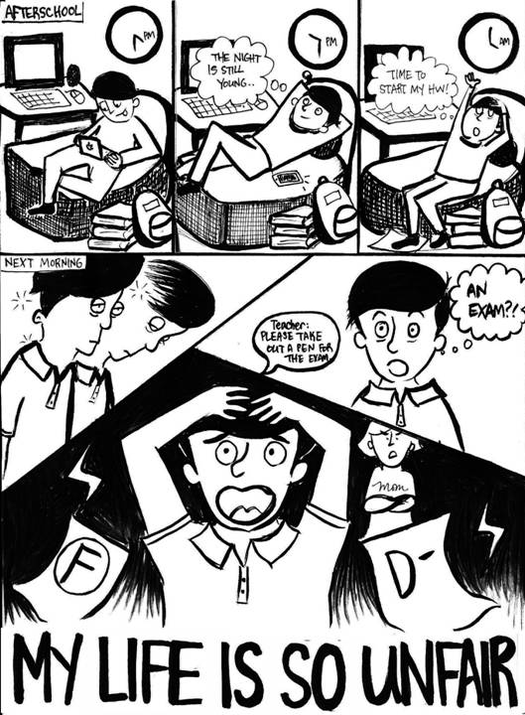

11. Where else do we see satire? Write about one example from either television, literature, print media, or the internet.

