“The Sniper” by Liam O’Flaherty
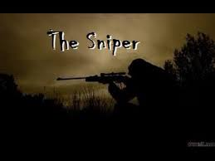 In “The Sniper,” how does the author use figurative language in the exposition to create an ominous and dangerous mood? Use evidence from the text to prove your answer.

(The story can be found on p. 437 for textual evidence.)

