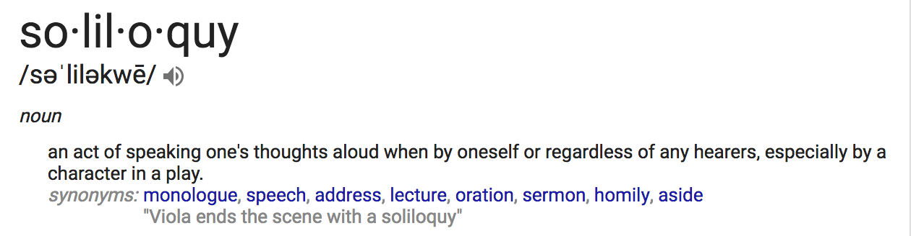
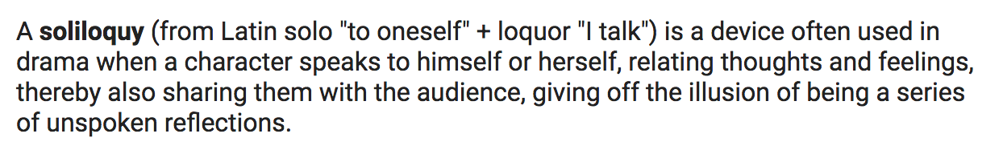
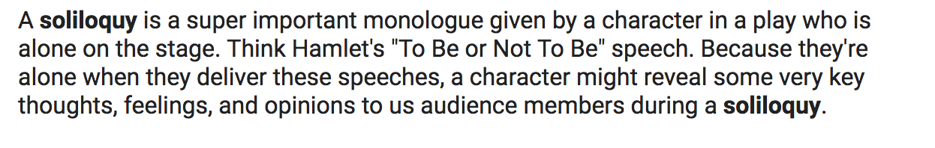

Excerpt from Hamlet’s first soliloquy:
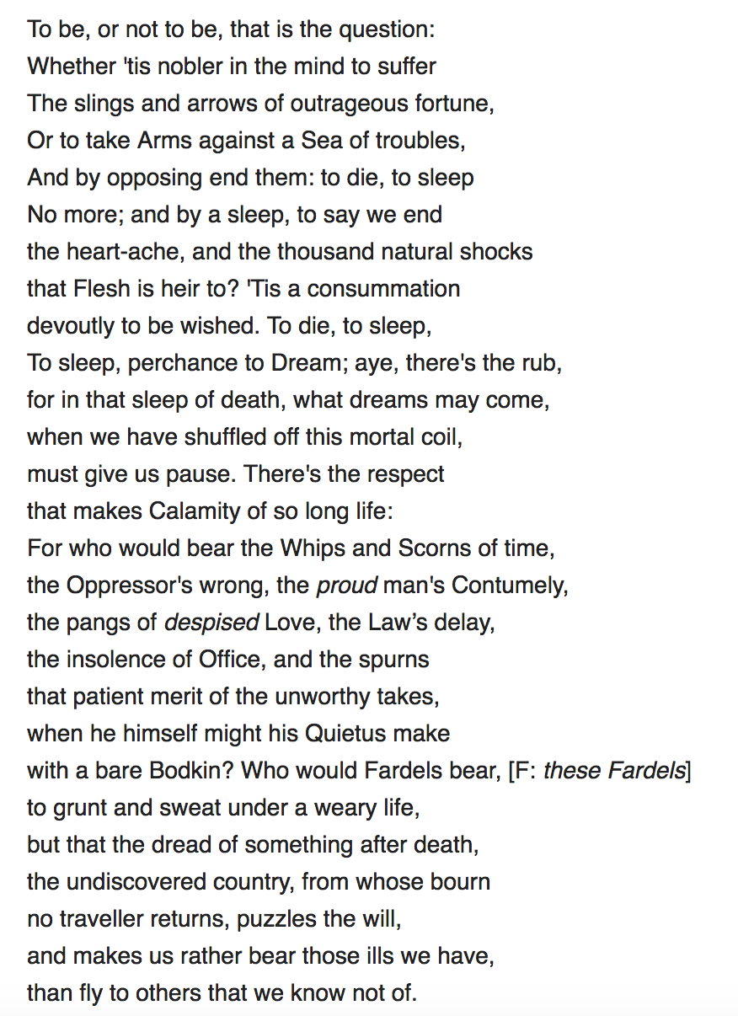
Objective:
Pretend you are Bertram Cates from Inherit the Wind. You are in jail, by yourself. You are on stage and you are going to give a soliloquy about your thoughts surrounding the trial you’re your actions. Write your thoughts / feelings and what you would want the audience to know.

_________________________________________________________________________________________________________________________________________________________________________________________________________________________________________________________________________________________________________________________________________________________________________________________________________________________________________________________________________________________________________________________________________________________________________________________________________________________________________________________________________________________________________________________________________________________________________________________________________________________________________________________________________________________________________________________________________________________________________________________________________________________________________________________________________________________________________________________________________________________________________________________________________________________________________________________________________________________________________________________________________________________________________________________________________________________________________________________________________________________________________________________________________________________________________________________________________________________________________________________________________________________________________________________________________________________________________________________________________________________________________________________________________________________________________________________________________________________________________________________________________________________________________________________________________________________________________________________________________________________________________________________________________________________________________________________________________________________________________________________________________________________________________________________________________________________________________________________________________________________________________________________________________________________________________________________________________________________________________________________________________.

