SSR during the Bless the Beasts and Children Unit
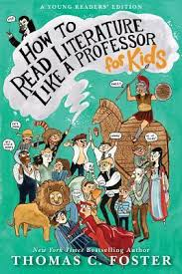
During this unit, all students will be required to read specified chapters from the same non-fiction book during SSR time. This book will provide you tools to help you gain a deeper understanding of the book.

Mandatory chapters to be read:

- Introduction: How’d He Do That?
- Chapter 1: Every Trip Is a Quest (Except When It’s Not)
- Chapter 2: Nice to Eat With You: Acts of Communion
- Chapter 7: …Or the Bible
- Chapter 11: Is that a Symbol?
- Chapter 13: Geography Matters
- Chapter 14: Marked for Greatness

You are responsible for the material in these chapters. Take notes. When you are finished, you may go back to reading your choice book for SSR.

You will receive a grade for your notes taken over the chapters.
As you read, separate your notes with headings for the 7 required reading sections as listed above. Reading and notes should be completed by end of class on Friday, November 3rd.

