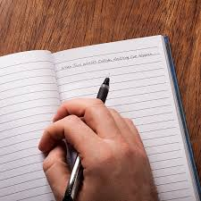
WRITER’S NOTEBOOK RESPONSE:

Write about a time in your life when you yearned for a material possession.

What did it look like?
How much did it cost?
Why did you want it?
Did you finally get it?
How did you get it?
What were the circumstances?
How did it make you feel?
What did it change in your life?
What did it mean for you to have this item?
Having this item meant __________ to you?

