______________________________
______________________________
______________________________
______________________________

Open-Ended Response

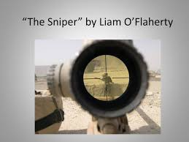

How does the setting affect the theme in “The Sniper”? Be sure to use evidence from the text and proper citations to support your response.

____________________________________________________________________________________________________________________________________________________________________________________________________________________________________________________________________________________________________________________________________________________________________________________________________________________________________________________________________________________________________________________________________________________________________________________________________________________________________________________________________________________________________________________________________________________________________________________________________________________________________________________________________________________________________________________________________________________________________________________________________________________________________________________________________________________________________________________________________________________________________________________________________________________________________________________________________________________________________________________________________________________________________________________________________________________________________________________________
________________________________________________________________________________________________________________________________________________________________________________________________________________________________________________________________________________________________________________________
________________________________________________________________________________________________________________________________________________________.

