Journal: Open-Ended Response
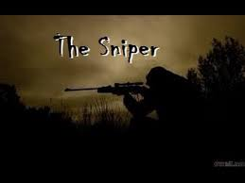
In “The Sniper,” how does the author use figurative language in the exposition to create an ominous and dangerous mood?

