“The Most Dangerous Game” by Richard Connell

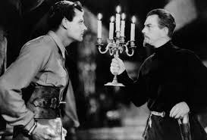

Closure Writing:

In your Writer’s Notebook, discuss who you feel is the most nefarious character so far in Richard Connell’s “The Most Dangerous Game”. (Grab a dictionary if you need to.)

Use 1 piece of evidence from the text to support your answer.

Include at least 1 CD-CX sentence in your answer. Highlight this sentence with a highlighter.

