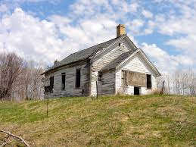

An old abandoned house,
White frame, stands on a hill
And looks down here on me.
A feeling always still lingers about its walls
Each time I look around.
The windows, vacant, stare.
There never is a sound. And yet it seems to live.
Its memories float inside
In rooms I cannot see,
A former life to hide of some time in the past
When children’s voices called
Where grasses now stand still
And dead tree limbs are sprawled. I wonder on
the house,
The life that once was there.
But it stands silent, mocking me,
Continuing to stare.
By Kay Whitaker

