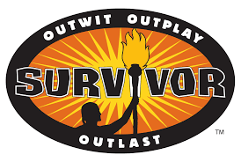What Is a Survivor?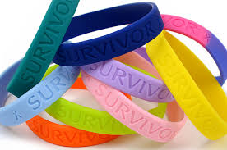

Step 1.
Make a list of people who you think are survivors or examples of survivors from books, televisions shows, or movies.
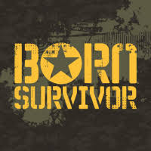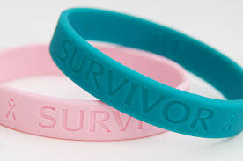

Step 2.
Choose one person from your list, and write a well-developed paragraph (8+ sentences) explaining how he or she is a survivor.

